SUSQI PROJECT REPORT TEMPLATE

This project report template should be used to report projects which have followed the Sustainable Quality Improvement ‘SusQI’ process. If your sustainable healthcare project does not apply SusQI methodology, please use our Case Study template instead (LINK)

This template is adapted from [SQUIRE 2.0](http://www.squire-statement.org/index.cfm?fuseaction=Page.ViewPage&pageId=471) reporting guidelines.

|  |  |
| --- | --- |
| Project Title:  Sherwood Forest Hospitals walking aid return and reuse scheme | Start/End date of Project:  April 2025  Date of Report:  May 2025 |
| Team Members:  Debs Kerry – Improvement Faculty Fellow (Deborah.kerry@nhs.net)  Samantha Musson – Head of Therapy Services (Samantha.musson@nhs.net)  Kirstie Pidduck – Physiotherapy Assistant  Wendy Bower – Physiotherapy Assistant  Robert Comins – Lead digital AHP |
| Background: | |
| Metal walking aids are extremely durable products whose usable life exceeds the use by a single patient. Walking aids can be repeatedly refurbished and reused, avoiding waste to landfill and reducing carbon emissions associated with manufacturing new aids. The net zero report set a target of 40% reuse of walking aids by 2025. Kings Mill Hospital (KMH) purchased 6786 walking aids in 2023-2024, at a cost of £81,300 and associated carbon emissions of 207,034 kg/CO2e. Despite a return and reuse scheme being launched in 2023, only 484 of the 6786 aids issued (7.1%) were returned and only 328 were reissued (4.8%). Many of these aids end up in landfill, cluttering people’s homes, or are passed onto other members of the public without assessing their suitability or safety. There is still a wide public and staff perception that walking aids are single use items. | |
| Specific Aims: | |
| 1. 30% of all walking aids issued by KMH will be returned for assessment of their suitability for re-use, by 30/06/25.  2. Reduce the number and carbon footprint of new walking aids purchased by KMH by 30% by 30/06/25.  3. Achieve a 50% financial saving on walking aid purchases for the financial year 2025/2026. | |
| Methods: | |
| The SUSQI framework was used to identify and deliver change and supports the sustainability principle of lean pathways:    Study the system  Limiting factors for this project were identified from previous PDSA cycles as:   * Return bins hidden from public view. * Inadequate internal & external PR campaign. * Limited internal ability to repair walking aids and cope with an increase in demand.   It was identified that purchasing publicly visible return bins, swapping walking aid supplier from NHS supply chain to British Red Cross and producing a media campaign had the potential to significantly reduce the carbon footprint and cost of walking aid provision at the organisation.  Design the improvement:  Key stakeholders for the project were identified and engaged with (see appendix 1.)  Swap from NHS supply to British Red Cross.  British Red Cross have a robust walking aid return and reuse scheme and reuse 85% of their returned equipment. Therapy services swapped suppliers from NHS supply chain to British Red Cross to access their reuse scheme, rather than using our clinicians time to re-issue aids. A satellite store was set up and all aids are now returned to British Red Cross for reuse/recycling, when new aids are delivered.  Tracking of walking aids  The trust didn’t previously track individual walking aids and could not recall faulty aids in the event of a MHRA recall. A nerve centre profile was designed to track the barcodes of aids issued to patients. A guide to issuing walking aids was produced and therapy wide education was provided via:   * Attending operational and team leader meetings. * Face to face walk rounds of all therapy teams. * WhatsApp group messages and departmental e-mail.   A weekly nerve centre report is collated and enables the trust to contact individuals with faulty aids if needed. Aids issued by nursing staff or outpatient areas not on nerve centre complete a paper log, which is added to the spreadsheet.  Designated walking aid return locations  The trust already had walking aid return locations in the therapy departments on all three sites. Our trust had previously specified these needed to be away from public view due to the perception of being visually unappealing. Following advice from NHSE, two new locations were set up at Kings Mill hospital that were publicly visible and accessible 24/7.  WRAP recycle now postcode locator.  The Trust re-registered its three return locations on the WRAP recycle now postcode locator.  Resources  Two walking aid return bins were purchased costing £1137. A portering contract was set up to transport the full bin from the main entrance down to therapy services (where British Red Cross collect from). Three bins were requested originally, to facilitate logistics of bin swaps and cleaning, but this was declined. The set-up cost and first year portering contract was £2280 and was funded by therapy services, based on the significant financial savings predicted. Clinical illustration designed posters and bin stickers, that charitable funds kindly funded the printing.  PR campaign  A key learning point from the 2023 campaign, was the inadequate engagement of key stakeholders and PR for the scheme. For this project an extensive internal and public PR campaign was completed via:   * Social media. * Trust internet and intranet. * Live trust brief interviews and trust bulletins. * Therapy operational & matrons’ meetings. * Screen savers and trust TV screens. * Local radio interviews and newspaper articles. * Place-based partnerships within the ICB.   The Trust Facebook article achieved one of the highest ever views on the page, with over 135,000 hits. This article was also picked up by the BBC, who ran a national article.  Patient information leaflets  Patient information leaflets about the scheme were designed and provided at the point of walking aid issue (Appendix 2). Patients were verbally encouraged to return aids when no longer needed. | |
| Measurement: | |
| Outcomes were measured to identify the sustainable value using the triple bottom line approach: *Patient outcomes:*  Negative patient outcomes weren’t expected, as the supply to patients should remain unchanged.  Reduced injury risk: The trust can now recall faulty walking aids. Improved returns will reduce the number of faulty or inappropriate aids passed/sold on to others, (cannot be objectively quantified).  Personalisation of needs: Public assessed for appropriate walking aids from health care professionals, rather than obtaining second hand.  Improved access to equipment and continuity of care: In the event of natural disasters, pandemics or civil conflict, local supply is more likely to continue. | |
| *Population outcomes:*  There are no predicted negative population outcomes as the access to the service remains unchanged and accessible to all population groups.  Promoting a culture of sustainability locally through awareness.  Engagement with other organisations to support walking aid projects. | |
| *Environmental sustainability:*  Data collected for 2023-2024 and 2024-2025:   * Carbon footprint for purchasing new walking aids & re-using walking aids. * Number of aids returned, and the percentage reused. * Yearly carbon footprint for walking aid provision at Sherwood Forest hospitals. | |
| *Economic sustainability:*  The cost of purchasing new walking aids was compared for 2023-2024 and 2024-2025.  The set-up cost for the walking aid return scheme was identified.  The overall cost of the walking aid service (purchases and returns) was compared for 2023-2024 to 2024-2025. | |
| *Social sustainability:*  Feedback was received from social media from the public and staff about preventing aids going to landfill and saving money. | |
| Results: | |
| Patient outcomes:  *Fostering community support and engagement:* There were many negative public Facebook comments about not having a returns scheme. We could listen, connect and respond to public demand.    *Reduced risk of injury*: More old and faulty aids were returned and not passed on to others, (this cannot be quantified). Having a barcode database improves patient safety by being able to recall faulty aids. However, adherence to logging the aids issued remains relatively low, with only approximately 30-40 aids being logged a month.  *Personalisation of needs:* By reducing second-hand walking aids being sold by the public, patients will need to obtain aids through healthcare providers. This should result in greater regulation of providing suitable walking aids (correct type and height of aids, shown how to use them properly).  *Improved access and continuity of care:* Aids being returned and reused locally has less potential for supply disruption (adverse weather, material shortages, civil unrest). | |
| Population outcomes:  No negative population outcomes were identified.  Several trusts around the country requested guidance for running their own walking aid return schemes, the positive findings from this project were able to influence the set-up of other schemes.  The public engaged significantly with the social media campaign, promoting a culture of sustainability locally through awareness. It also prompted other departments within the organisation to consider setting up equipment return schemes, for example return of CPAP and nebuliser machines. | |
| Social outcomes:  The public and staff engagement on the social media campaign was extensive. Many of the community were angry about the lack of a return scheme, the aids going to landfill and associated money wasted. We were able to respond to the local desire to reuse aids and enable the local community to be able to do what they perceived as ‘the right thing’ environmentally and financially. | |
| |  |  |  |  |  |  |  |  |  |  |  |  |  |  |  |  |  |  |  |  |  |  |  |  |  |  |  |  |  |  |  |  |  |  |  |  |  |  |  |  |  |  |  |  |  |  |  |  |  |  |  |  |  |  |  |  |  |  |  |  |  |  |  |  |  |  |  |  |  |  |  |  |  |  |  |  |  |  | | --- | --- | --- | --- | --- | --- | --- | --- | --- | --- | --- | --- | --- | --- | --- | --- | --- | --- | --- | --- | --- | --- | --- | --- | --- | --- | --- | --- | --- | --- | --- | --- | --- | --- | --- | --- | --- | --- | --- | --- | --- | --- | --- | --- | --- | --- | --- | --- | --- | --- | --- | --- | --- | --- | --- | --- | --- | --- | --- | --- | --- | --- | --- | --- | --- | --- | --- | --- | --- | --- | --- | --- | --- | --- | --- | --- | --- | --- | | Environmental sustainability:  Increase in walking aids returns  In 2023-2024 only 484 walking aids (7%) were returned to KMH for reuse and only 328 (5%) were re-issued. 469 walking aids were returned in the first 3 months after the re-launch, with the monthly average increasing from the 40 to 157.  Overall, in 2024-2025 there was a 77% rise in the number of walking aids returned to 856 and a 97% increase in the number of walking aids re-issued to 647. This equated to approximately 28% of walking aids that were issued being returned and 21% being re-issued.  Walking aid returns numbers from 2023-2024 to 2024-2025.   |  |  |  |  |  |  |  | | --- | --- | --- | --- | --- | --- | --- | |  | Returned 23/24 | Re-issued 23/24 | Returned 24/25 | Re-issued 24/25 | ↑ returns No  From 23/24-24/25 | ↑ returns %  From 23/24-24/25 | | Frames | 108 | 82 | 203 | 162 | ↑95 | ↑88% | | Crutches (pairs) | 339 | 234 | 576 | 439 | ↑237 | ↑70% | | Sticks | 37 | 12 | 77 | 46 | ↑40 | ↑108% | | Yearly Total | 484 | 328 | 856 | 647 | ↑372 | ↑77% | | Monthly Average | 40 | 27 | 71 | 54 | ↑31 | ↑78% |   A special cause improvement in the monthly number of walking aids returned is clearly demonstrated following the project launch:  SPC chart for walking aid returns at KMH pre and post campaign launch.    Carbon emissions data from new walking aids purchases for Therapy services  By reusing more aids and swapping to British Red Cross, in 2024/2025 we purchased 1937 fewer new aids and reduced the emissions by 53,505kgCO2e (32%) from 167,533 kgCO2e, to 114,029 kg/CO2e. (The carbon emissions data for new walking aids can be found in appendix 3).  Comparison of 2023-2024 to 2024-2025 kgCO2e savings from new walking aid purchases   |  |  |  |  |  |  |  | | --- | --- | --- | --- | --- | --- | --- | |  | **New aids purchased 23/24** | **New aids purchased 24/25** | **kgCO2e from new aids 23/24** | **kgCO2e from new aids 23/24** | **kgCO2e ↓ from new aids** | **% reduction** | | **Frames** | 2170 | 1535 | 140,268 | 99,222 | 41,046 | 29% | | **Crutches (pairs)** | 911 | 535 | 18,001 | 10,572 | 7,429 | 41% | | **Sticks** | 1706 | 780 | 9,264 | 4,235 | 5,029 | 54% | | **Total** | 4787 | 2850 | 167,533 | 114,029 | 53,504 | 32% |   Carbon emissions from walking aids supplied by British Red Cross  The carbon emissions calculations from reusing walking aids can be found in appendix 3. British Red Cross reuse 85% of the equipment returned to them. Therefore, a presumption was made that 85% of the aids they supplied were re-used and 15% were new. The carbon emissions for the 205 walking aids British Red Cross supplied in 2024/2025 was 1667 kgCO2e. (Appendix 4).  Carbon emissions from procuring returns bins.  Two, 1100L drop down lid bins were purchased for returns bins. The carbon emissions for both bins were 430kgCO2e and can be broken down as:  1 bin:  69.5kg LDPE (2.59kgCO2e/kg) = 180kgCO2e  13kg mild steel zinc plated towing mechanism (2.71kgCO2e) = 35.23kgCO2e  Total emissions for Walking aids supplied by Therapy services KMH.  The carbon emissions for 2024-2025 for walking aids supplied was 115,696 kgCO2e this was a 51,837 kgCO2e (31%) reduction. |   Economic sustainability:  In 2023/2024 Therapy services at Kings Mill hospital purchased 4787 walking aids, costing £60,435. The emergency department purchased a further 1999 crutches, costing a further £20,8777, totalling 6,786 walking aids and £81,312.  Following the swap of Therapy services to British Red Cross on the 01/02/2025, walking aids in therapy services were funded via Nottingham and Nottinghamshire ICS rather than by therapy services.  The number of walking aids purchased by therapy services in 2024-2025 reduced by 40% to 2850, saving £19,773. This reduction is a combination of reusing more existing aids and not having to purchase aids following the swap to British Red Cross.  The purchase cost of the two returns bins was £1137.72 including VAT. The yearly portering cost is £1,142.44 (based on an hourly rate of £21.97 for one hour per week). The total cost for bin purchases and portering in 2024/2025 was £2,280. When the bin costs are subtracted from the savings from new walking aid purchases, a total saving of £17,493 (29%) was made.  Financial cost of walking aids for Therapy services from 2023/2024 to 2024/2025   |  |  |  |  | | --- | --- | --- | --- | |  |  |  |  |  |  |  |  |  |  | | --- | --- | --- | --- | --- | |  | Quantity of walking aids purchased | Walking aids cost | Bin Costs (purchases & portering) | Total cost including returns scheme. | | 2023-2024 | 4787 | £60,435 | £0 | £60,435 | | 2024-2025 | 2850 | £40,662 | £2,280 | £42,942 | | Change | -1937 | -£19,773 | +£2,280 | -£17,493 | | |
| Discussion: | |
| The original projective objectives were:   1. 30% of all walking aids issued by KMH will be returned to the Trust for assessment of their suitability for re-use, by 30/06/25 2. Reduce the number of new walking aids purchased by KMH by 30% by 30/06/25. 3. Reduce the carbon footprint of new walking aid purchases by 30% by 30/06/25   The 856 walking aids returned to KMH in 2024/2025, is 28% of the walking aids issued. This is a 77% rise and with a further three-months of returns data to be included before the target date, this will surpass the 30% target. Of the 856 returned, 647 were re-issued (97% rise). A key factor in the reuse rise was the clinician’s acceptance to supply aids with signs of use. Previously aids that were physically damaged, but safe to use (e.g. scratched aids) were scrapped.  The number of new walking aids purchased by therapy services reduced by 36% from 4787 to 3055, surpassing the 30% target.  The carbon footprint of purchasing walking aids in 2024/2025 was 51,837 kgCO2e lower than 2023/2024, this was a 31% reduction and surpasses the 30% target. This has saved the same kgCO2e emissions as driving a car 5.3 times around the world.  Financial savings played a significant role in securing funding for the returns scheme. Despite the returns project not going live until month ten of the financial year, a financial saving of £17,493 was made in 2024/2025, when the set-up cost of the returns scheme was factored in (£2,280).  The bariatric walking aids supplied by Red Cross have a maximum user weight of 226 kg, which is insufficient for some of our patients. The maximum user weight for the NHS supply chain bariatric walking aids previously purchased was 300kg. Therefore, it was agreed therapy services would continue to purchase a small number of NHS supply chain bariatric frames, for patients who exceed the maximum user weight of the Red Cross bariatric frames.  For 2025/2026 the cost for walking aid provision has been estimated at £2,770 for therapy services. This comprises of:   * Yearly portering cost of £2,280, based on 1 hour per week. * Purchase of approximately 10 specialist bariatric frames from NHS supply chain (£490).   This will be a further saving of £40,672 for 2025/2026 (95%), compared to 2024/2025. | |
| Conclusions:  The financial cost for walking aid supply for therapy service at KMH in 2024-2025 reduced by £17,493 (29%), once the startup costs of the return scheme were factored in (£2280). The carbon emissions associated with the supply of walking aids to therapy services for this period reduced by 51,837 kgCO2e (31%). Over 850 walking aids were returned to KMH in 2024/2025, which is a 77% increase from the previous year, despite the project not being launched until month ten of the financial year. Following the launch the monthly average walking aid returns increased from 40 to 157, which is a 293% increase.  The predicted financial saving for walking aid provision for 2025/2026 for Therapy services is a further £40,600. This project needs to be quickly rolled out to KMH & Newark ED, with the potential to save a further £30,000 a year.  Ongoing work is required by therapy services to ensure ongoing staff and public PR continues, to maximise the returns. Work needs to be completed to improve the adherence to logging issued walking aids and consideration of a purchase of a third bin is required to improve emptying logistics.  There are still some ongoing issues with the portering arrangements for swapping full returns bins. My recommendation is to remove the portering contract and for therapy assistants to transfer returned aids from the main reception to therapy services. This would reduce the total walking aid cost to £490 a year down from £60,435 in 2023-2024. | |
| References and Resources | |
| [NHS England » Walking aid reuse](https://www.england.nhs.uk/ahp/greener-ahp-hub/specific-areas-for-consideration/walking-aid-reuse/)  <https://www.england.nhs.uk/greenernhs/a-net-zero-nhs/>  [20231004 Walking Aid Return and Reuse Planning Pack_2023 - Central Commercial Function (CCF) Best Practice Hub - FutureNHS Collaboration Platform](https://future.nhs.uk/CCF_Hub/view?objectID=181651237)  [Walking Aids Carbon Footprint Recorder - Central Commercial Function (CCF) Best Practice Hub - FutureNHS Collaboration Platform](https://future.nhs.uk/CCF_Hub/view?objectID=126198469) | |
| Appendices | |

Appendix 1. Key stakeholder engagement matrix



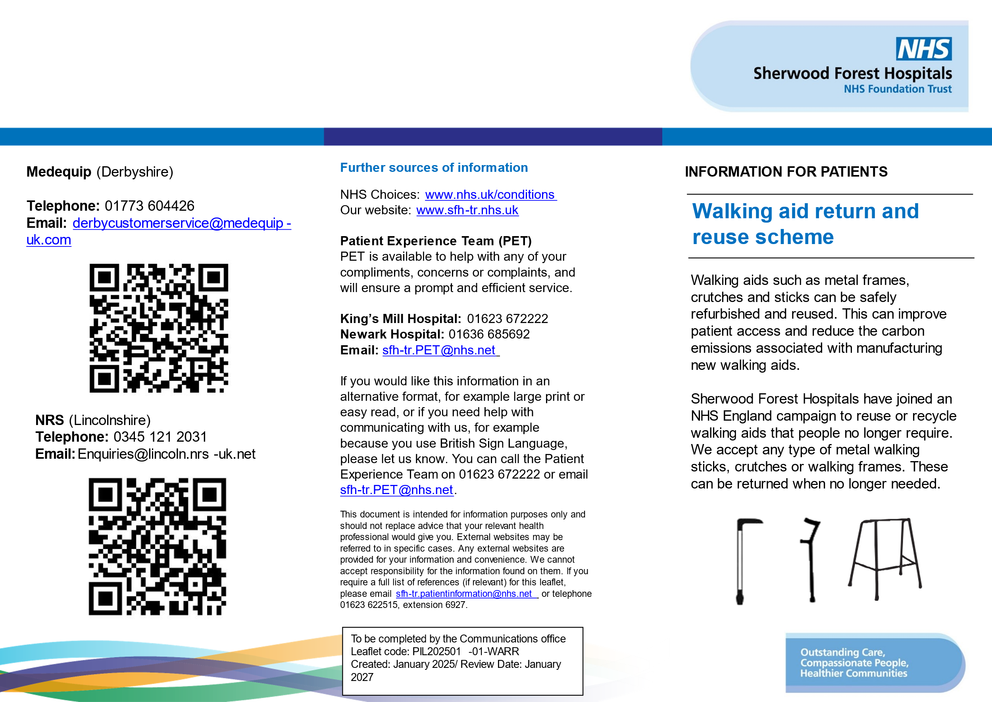Appendix 2: Walking aid PIL

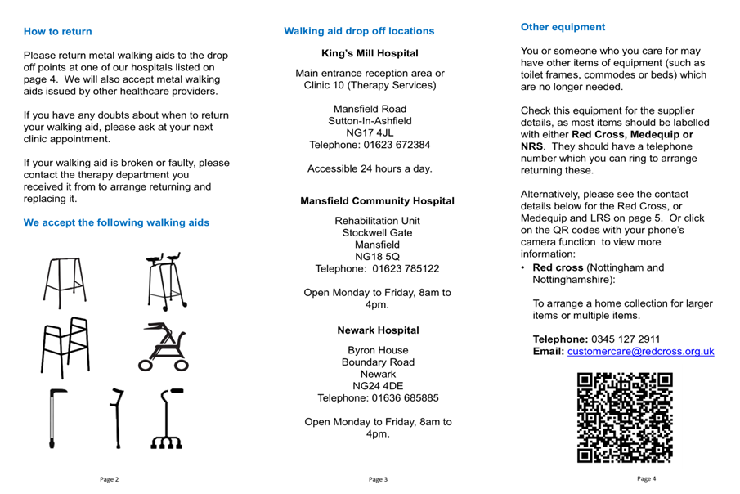

Appendix 3: Carbon emissions data for new and reused walking aids

kgCO2e saving per aid from reusing (compared to purchasing new).

|  |  |  |  |
| --- | --- | --- | --- |
|  | kgCO2e per each new aid supplied | kgCO2e per each re-used aid* | kgCO2e saving by re-using  each aid |
| Frames | 64.64 | 0.3 | 64.34 |
| Crutches (pairs) | 19.76 | 0.3 | 19.46 |
| Sticks | 5.43 | 0.16 | 5.27 |

Appendix 4: Carbon emissions for British Red Cross supplied walking aids Feb/Mar 2025

|  |  |  |  |  |
| --- | --- | --- | --- | --- |
|  | Number | kgCO2e for 85% refurbished aids | kgCO2e for 15% new aids | Total kgCO2e for BRC aids |
| Frames | 163 | 41.7 | 1551.4 | 1593 |
| Crutches (pairs) | 15 | 3.9 | 39.52 | 43 |
| Sticks | 27 | 3.7 | 27.2 | 31 |
| Total | 205 | 49.3 | 1618.12 | 1667 |

*The carbon emissions for re-using aids have been estimated based on using one clinell wipe to clean each aid and all ferrules being replaced.

|  |  |  |  |
| --- | --- | --- | --- |
| **Critical success factors**  Please select one or two of the below factors that you believe were most essential to ensure the success of your project changes. | | | |
| **People** | **Process** | **Resources** | **Context** |
| Patient involvement and/or appropriate information for patients - to raise awareness and understanding of intervention  Staff engagement  MDT / Cross-department  communication  Skills and capability of staff  Team/service agreement that there is a problem and changes are suitable to trial (Knowledge and understanding of the issue)  Support from senior organisational or system leaders | clear guidance / evidence / policy to support the intervention.  Incentivisation of the strategy – e.g., QOF in general practice  systematic and coordinated approach  clear, measurable targets  long-term strategy for sustaining and embedding change developed in planning phase  integrating the intervention into the natural workflow, team functions, technology systems, and incentive structures of the team/service/organisation | Dedicated time  QI training / information resources and organisation process / support  Infrastructure capable of providing teams with information, data and equipment needed  Research / evidence of change successfully implemented elsewhere  Financial investment | aims aligned with wider service, organisational or system goals.  Links to patient benefits / clinical outcomes  Links to staff benefits  ‘Permission’ given through the organisational context, capacity and positive change culture. |