January 2012

HOW-TO GUIDE: REDUCE DIALYSIS WASTE – EQUIPMENT INVENTORY

Use of dialysis consumables makes up a big proportion of the greenhouse gas emissions from kidney care. Renal units are saving tens of thousands of pounds and tonnes of carbon dioxide (CO2) each year by making just small changes to the equipment used for each dialysis treatment. Leaving unnecessary items unopened saves far more money and carbon than recycling them after use, because most of the impact is due to their manufacture rather than waste disposal.

“But everything we use is needed!”
Are you sure? Other units have found that they are opening whole dressings packs but really only needed some gauze swabs, or that a smaller bicarbonate cartridge would do just as well...

“How can such small changes make any difference?”
Dialysis units carry out so many treatments, that savings quickly multiply up. A 20 station unit may be running over 18,000 treatments per year. Even reducing equipment by a single 10ml syringe costing 12p will save £2,160 and approx. 1,200kg CO₂e per year.

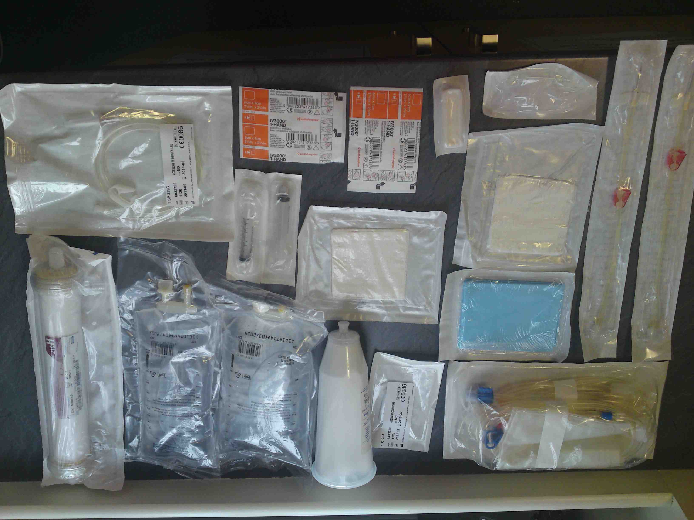
STEP 1. Inventory – identify opportunities
Lay out all the equipment that is used for the standard dialysis treatment. Check with colleagues to make sure that you have included everything. Go through each item and ask,
- Is this always needed?
- Is everything in the packet used?
- Is anything doubled up - provided in more than one packet?
- Would a smaller one do?
- Could we change the way we do things so that we didn’t need to use it?

STEP 2. Plan changes
Some changes may need the Trust to invest in new equipment, or for the department to open a dialogue with suppliers. Others will just need you and your colleagues to do things slightly differently – but even that may take a little thought. How will your colleagues find out about your proposal, and will they understand why it is worthwhile? Make sure you get them on board.

STEP 3. Calculate savings
1. Procurement (manufacture & distribution costs)
£: How much are you not spending to buy the unneeded items? Multiply their unit price by the number of items previously used per year.
CO₂: You can use the cost savings to work out a rough estimate of carbon savings too. Multiply £ by 0.57 to give an answer in kg CO₂e.
2. Waste disposal
£: To calculate savings, first determine whether the item would have been disposed of in the domestic or clinical waste stream – if possible, find out from your Trust how much these disposal routes cost per tonne. As a guide, clinical waste may cost £400-700 per tonne, while domestic waste is closer to £80-100 per tonne, and recycling is usually cheaper. Next, weigh your unused item and multiply by the number of dialysis treatments per year to give a total weight of waste saved per year. Finally, multiply this by the appropriate waste disposal cost.
CO₂: The carbon emissions from waste disposal depend upon the material and the route of disposal. As a rough estimate, incineration of clinical waste produces approx. 1.8 tonnes CO₂e per tonne of waste, while landfill (domestic waste) produces 0.04 tonnes CO₂e per tonne of waste plastic, or 0.55 tonnes CO₂e per tonne of waste paper or cardboard.

STEP 4. Share your experiences!
Keep in touch with the Green Nephrology Network at http://sustainablehealthcare.org.uk/green-nephrology. Please share your ideas, successes and frustrations via the Network forum, or post a blog article about how you are getting on.

Frances Mortimer
frances.mortimer@sustainablehealthcare.org.uk
23 January 2012
Tips from dialysis units:
- Hanging saline bags for reinfusion may not be needed any longer as many dialysis machines now provide online infusion.
- Changing the size of bicarbonate cartridges can reduce packaging and bicarbonate wastage.
- Dressings packs can be slimmed in consultation with suppliers, or substituted with individual items such as gauze swabs.
- In Cornwall, no longer setting up stations in advance has saved 5 full sets of dialysis equipments per week.
- Use of plastic Griff Bins® for routine clinical waste is expensive and may not be necessary.
- Units can save tens of thousands per year and eliminate the need for acid canisters by arranging for central acid delivery.
More case studies: http://map.greenerhealthcare.org/green-nephrology-projects

Conversion factor for medical instruments, taken from Annex 13 of 2010 Guidelines to Defra / DECC's GHG Conversion Factors for Company Reporting
Emissions factors from DEFRA (2009), taken from Connor et al., The carbon footprint of a renal service in the United Kingdom, Q J Med, doi:10.1093/qjmed/hcq150

