SUSQI PROJECT REPORT
From Hospital to Home: Evaluating the Impact of Subcutaneous Vedolizumab in Inflammatory Bowel Disease (IBD) Care

Start date of Project: April 2026
Date of Report: October 2026

Team Members:
- Sophie Young, IBD Clinical Nurse Specialist, Clinical Endoscopist.
- Jamie Catlow, Consultant Gastroenterologist

This quality improvement project aimed to evaluate the clinical, environmental, social and financial impact of transitioning eligible Inflammatory Bowel Disease (IBD) patients from hospital-based intravenous (IV) Vedolizumab infusions to home-administered subcutaneous (SC) Vedolizumab injections.

Background:
Vedolizumab is an established maintenance treatment for patients with IBD and can be administered either as:
- Intravenous infusion (300 mg every 4, 6 or 8 weeks – only 8 weekly is licensed, although in some refractory cases dosing is given 4 or 6 weekly).
- Subcutaneous injection (108 mg fortnightly – including those optimised to 4 weekly who switch).

Newcastle Hospitals NHS Foundation Trust is one the largest prescribers of biological agents for inflammatory bowel disease in the country, caring for over 400 patients receiving Vedolizumab annually. Some biologic medications, such as Vedolizumab, are initiated with regular IV infusions. Patients often commute long distances for appointments and infusions.

It is estimated that patient transportation accounts for up to a third of the carbon cost of IBD care. Our specialist IBD service provides care for patients from a wide geographical area, spanning from Whitehaven on the northwest coast (96 miles west), down to Teesside (50 miles south). It is not known how our patients choose to attend appointments from different geographical areas, or the carbon costs of these decisions.

However, National guidelines are not prescriptive regarding the modality of IBD biologic medicines, as they have a similar efficacy intravenously or subcutaneously, but promote holistic patient centred decision making (BSG 2025).

This project therefore sought to support NHS sustainability objectives by reducing the environmental impact associated with hospital-based infusions by switching eligible patients to subcutaneous Vedolizumab closer to their home, maintaining high-quality patient care.

Locally, there is limited understanding about the service users' perceptions of how carbon costs would influence their decision making about treatments, their experiences of treatment modalities in hospital and at home, or how they choose to attend appointments. There is currently no easy low carbon way to attain experience feedback.

Specific Aims:
- To achieve 75% uptake of maintenance subcutaneous (SC) Vedolizumab among eligible patients in place of Intravenous (IV) Vedolizumab, within 12 weeks of project implementation.
- To quantify the environmental and resource impacts associated with hospital based IV administration, compared with homecare SC administration, assessing carbon footprint, patient travel, consumables, staffing requirements, waste generation and financial impact.
- To explore patients’ perspectives and experiences of intravenous (IV) versus subcutaneous (SC) treatment, including their perceptions of environmental sustainability and the factors that influence treatment preferences and decision-making.

Methods:
Studying the system
Baseline activity data was collected to establish the number of patients receiving IV and SC Vedolizumab at Newcastle Hospitals NHS Foundation Trust and to quantify the associated hospital attendance over a 12-month period. This allowed us to understand the extent of change possible.

Data was obtained from the IBD service in May 2026 and included the number of patients receiving IV Vedolizumab and the frequency of administration, as outlined in table 2. 7 patients were excluded form the data as they had previously switched to SC, however then converted back to IV.

Table 1. Number of Patients Receiving IV Vedolizumab at Newcastle Hospitals NHS Foundation Trust (May 2026)
Frequency of IV Vedolizumab | Number of Patients
8-weekly | 163
6-weekly | 7
4-weekly | 11
Total | 181

Using this baseline data, the annual number of hospital attendances required for IV Vedolizumab administration was calculated based on three different treatment schedules. The annual attendance was calculated as follows:
- 8-weekly regimen: 163 patients × 6 attendances per year = 978 annual attendances
- 6-weekly regimen: 7 patients × 8 attendances per year = 56 annual attendances
- 4-weekly regimen: 11 patients × 13 attendances per year = 143 annual attendances

Based on these figures, the service delivered a total of 1,177 IV Vedolizumab infusion attendances annually across the 181-patient cohort. Baseline data also demonstrated that 231 patients were receiving SC Vedolizumab during the same period, providing context for the existing uptake of SC therapy within the service.

Implementing the change
The proposed transition from IV to SC Vedolizumab was discussed with the wider IBD multidisciplinary team during the annual departmental meeting. Stakeholders involved included consultant gastroenterologists, gastroenterology registrars, pharmacists, IBD clinical nurse specialists, research nurses, and nursing staff from the Medical Day Case Unit (MDCU), where Vedolizumab infusions are administered.
Patient engagement was undertaken through routine clinical care. Patients established on IV Vedolizumab were approached while attending the MDCU and invited to complete patient questionnaires. The option of switching from IV to SC Vedolizumab was discussed by the pharmacist during scheduled infusion appointments, with patients provided information about both treatment routes and given the opportunity to ask questions before making a decision. The IBD team also discussed treatment options during outpatient reviews and could refer suitable patients directly to the pharmacist and MDCU team to facilitate conversion. Patients commencing Vedolizumab treatment were switched to SC administration following completion of IV loading doses as appropriate in agreement with the patient.
The implementation process was supported by the pharmacy team, who played a central role in identifying patients, providing information, and supporting decision-making. The MDCU nursing team were already experienced in the administration and monitoring of Vedolizumab, and as SC Vedolizumab was already being used within the service, no additional staff training was required. Where required, further support for patients could also be provided by the homecare company.
No formal exclusion criteria or contraindications specific to SC Vedolizumab were identified in comparison with IV administration. A small number of patients subsequently reverted from SC to IV treatment because of loss of response, although it is not possible to determine whether this was related to the route of administration or the underlying disease course. Patients receiving SC Vedolizumab continued to receive routine monitoring through outpatient review and blood tests, typically at least every six months. Patients who had switched to SC and subsequently returned to IV treatment were excluded from the project analysis.
The service included 11 consultant gastroenterologists, and approaches to discussing treatment options varied between clinicians. Pharmacy teams were a key driver of the change programme, recognising the potential operational and cost benefits associated with increased uptake of SC treatment. A reduction in the acquisition cost of SC Vedolizumab from July 2026 further supported the transition towards home-based administration.
Progress Towards Practice Change
Table 2 provides updated data on the uptake of SC administration following the intervention.

Table 2. Outcome regarding potential switch from IV to SC Vedolizumab based on data from pharmacist (Sept 2026). Total 265 patients.
Outcome | Number of Patients | Percentage (%)
Not suitable for switch | 44 | 17
Declined switch | 38 | 14
Accepted on first discussion | 24 | 9
Agreed at next infusion | 41 | 15
Yet to be approached | 118 | 45

Of the eligible patients who have been approached by Sept 2026 (currently 103 patients) and made a decision, 65 agreed to switch treatment and 38 declined, representing an acceptance rate of approximately 63%.

The pharmacist's September 2026 dataset included 265 patients and therefore represented a larger cohort than the baseline population of 181 patients receiving IV Vedolizumab. To enable comparison with baseline activity and estimate the potential impact of the intervention, the observed acceptance rate of 63% was applied to the baseline IV cohort. This estimated that approximately 114 patients (63% of 181) could transition from IV to SC Vedolizumab.

Measurement and Results.
Patient outcomes:
As the evidence base already demonstrates comparable clinical effectiveness, with national guidelines reporting similar efficacy intravenously or subcutaneously, we do not anticipate any changes to patient clinical outcomes.

We conducted a patient survey (results in the social impacts section), and made joint decisions with patients to ensure patients continue to receive appropriate and patient centred care.

We continue to monitor if there are any serious adverse side effects, however this is likely to occur regardless of administration method. No clinical issues related to a change from IV to SC Vedolizumab have been identified.

The primary benefits observed related to patient experience, reduced hospital attendances, released clinical capacity and environmental impact.

Population outcomes:
As the option for IV Vedolizumab remains available, no negative outcomes were identified during the project. Patients who were unsuitable for SC Vedolizumab, or who preferred to continue IV treatment, retained access to hospital-based infusions. This ensured that patients with additional support needs, physical or cognitive limitations, or other barriers to self-administration were able to continue receiving appropriate treatment, ensuring equitable access to care and mitigating potential inequalities arising from the change in treatment delivery.

It is anticipated that the project will reduce delays in accessing the MDCU, improving efficiency and timeliness of care for wider cohorts of patients, however it was not possible to capture data within the time frame.

Environmental sustainability:
Methodology:
A cradle-to-grave carbon footprint analysis was used to estimate the items greenhouse gas (GHG) emissions. Data was provided on the equipment used to deliver Vedolizumab IV in hospital or self-administered at home and were carbon footprinted using a process-based carbon footprint analysis. Items were weighed by the team and materials identified.

Data was obtained from previous studies by the Centre for Sustainable Healthcare and other references. Where data was not available, calculations were made based on the weight and material of the product. Material weights were converted into GHG emissions using emission conversion factors taken from the Department of Energy Security and Net Zero (DESNZ)’s Greenhouse Gas Reporting Conversion Factors 2026 database, ICE V4.0 database and primary research papers and LCAs. The analysis included GHG emissions associated with primary materials production, transport, and disposal.

Waste emissions were calculated by amount of waste (tonnes) and the UK emission factor of average emissions by waste stream. The emission factor for clinical waste is 1074 kgCO₂e, dry mixed recycling is 172 kgCO₂e and domestic waste is 172 kgCO₂e.

Travel emissions were calculated by the distance travelled (miles or km), mode of travel and the UK emission factor by mode. The emission factor for average size petrol car is 0.334 kgCO₂e per mile/0.208 kgCO₂e per km; average local bus travel per passenger.km is 0.128 kgCO₂e and rail travel is 0.040 kgCO₂e per passenger.km.

Results:
The carbon footprint of a single IV attendance was estimated to be 15.35 kgCO₂e, with patient travel accounting for the majority of emissions (13.56 kgCO₂e per visit). Based on approximately 181 patients, total annual emissions were estimated at 19,371 kgCO₂e. Total annual emissions for 181 patients receiving SC treatment were estimated at 1,083.3 kgCO₂e.

The uptake of SC self-administration depends on multiple factors. Total emissions from varying degrees of uptake can be modelled and are shown below in table 3.

Table 3. Emissions (kgCO₂e) from SC and IV administration at 25, 50, 63, 75 and 100% uptake
 | 0 | 25 | 50 | 63 | 75 | 100
SC emissions | 0.0 | 251.8 | 503.5 | 634.5 | 755.3 | 1,007.1
IV emissions | 19,371.7 | 14,528.8 | 9,685.9 | 7,167.5 | 4,842.9 | 0.0
Total emissions (kgCO₂e) | 19,371.7 | 14,780.5 | 10,189.4 | 7,802.0 | 5,598.2 | 1,007.1
Yearly savings (kgCO₂e) | 0.0 | 4,591.2 | 9,182.3 | 11,569.7 | 13,773.5 | 18,364.6

This shows that even a relatively small percentage change from IV to SC Vedolizumab can have significant reductions in overall emissions. Applying the observed acceptance rate of 63% to the baseline cohort suggests a potential reduction of approximately 11,570 kgCO2e per year.
Figure 1. Modelled emissions based on varying degrees of adoption of SC self-administration
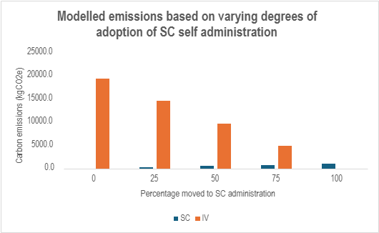

Economic sustainability:
Methodology:
Financial impact was assessed by comparing the costs associated with IV and SC Vedolizumab treatment pathways. The cost of IV Vedolizumab administration was calculated using the medication acquisition cost and all consumables required for cannulation, blood sampling and infusion delivery (table 4).

Table 4. Cost per IV Vedolizumab Infusion
Item | Cost (£)
Tourniquet | 0.06
Gold venous tube | 0.12
Purple venous tube | 0.08
Clinell wipes (x6) | 0.06
Hexi hub chlorhexidine wipe | 0.01
Infusomat giving set | 1.46
5 ml syringe | 0.02
21G needle | 0.06
Gloves (x3 pairs) | 0.03
Apron (x3) | 0.03
Cannulation pack | 5.95
Specimen bag | 0.02
Opsite dressing | 0.06
250mls NaCl 0.9% (for intravenous infusion) | 0.55
Vedolizumab 300mg vial for infusion | 1206.00
Total per infusion (consumables and medication) | 1,214.51

The cost of SC Vedolizumab was calculated using the acquisition cost for one pre-filled injection pen administered at home (£301.50). Based on fortnightly administration, each patient was identified to require 26 pens per year.

Costs associated with staff time, pharmacy preparation, clinical waste disposal, hospital infrastructure and estate costs were not quantified for either route. Sharps bins and clinical waste collection are funded by the manufacturer and homecare provider, generating no additional waste disposal costs to the Trust Additional costs associated with patient training, home administration, medication delivery and waste disposal were not included in the analysis.

Results:
Patients who receive IV treatment on an eight-weekly regimen, this equates to an average of 6.5 hospital visits per year (or 13 over 2 years), resulting in an annual treatment cost of £7,894.32 per patient.

The financial cost of SC therapy is £301.50 per injection pen. With treatment administered fortnightly, each patient requires 26 injections per year, resulting in an annual treatment cost of £7,839 per patient.

The difference in costs result in an annual saving of £55.32 per patient who moves to SC delivery. Assuming a 63% transition (or 114 patients out of 181 total patients), cost reduction is estimated to be £6,306.50.

There are additional cost-efficiency gains from reallocation of nursing time, estimated to be £13,900 per year (Based on £25 per hour for a Band 5 nurse including on-costs). While this does not necessarily result in a direct financial saving, it creates additional clinical capacity that can be redirected to other patients and activities within the service.
Social sustainability
Nursing resource utilisation
Each IV Vedolizumab infusion requires approximately 45 minutes of nursing time. Based on an estimated 114 patients transitioning to SC treatment, this would avoid approximately 742 infusion attendances per year, releasing around 556 hours of nursing time. This is equivalent to almost 70 eight-hour nursing shifts (and generates £13,900 in cost efficiency as mentioned above).
Following initial education appointments, medication is delivered directly to patients’ home through the existing homecare pathway. No routine additional nursing input is required following the initial training appointment unless specific concerns or administration issues are identified.
Ongoing prescribing and supply are managed through established pharmacy processes. As the pharmacy team would already be responsible for prescribing and coordinating treatment for these patients, the transition to SC administration is not expected to substantially increase pharmacy workload.
Patients:
The patient survey included 14 respondents, all of whom are currently receiving IV Vedolizumab.

All respondents (100%) reported a very positive experience of attending hospital for infusion treatment. Patients highlighted friendly and supportive staff, feeling safe and well monitored, efficient appointments, a convenient location, and reliable appointment scheduling as aspects of the service that worked particularly well.

11 patients travelled via private car, with 1 each using the bus, metro or walking. 11 travelled alone, and 3 were accompanied by a family member. In terms of accessibility, 79% reported travelling to hospital was easy and 21% reported travelling was fairly easy.

The main difficulties identified by patients relate to parking, accessibility via public transport, and the time required to travel to and from the service. Each visit incurs car park costs. Current pricing structure is £4 for a stay of between 1 and 2 hours. Across hospital visits, costs to the patient cohort are £5,048 cumulatively.

Treatment preferences
When asked about treatment preferences, 9 (64%) stated they prefer IV. 1 (7%) that they prefer SC and 4 (29%) were unsure. Key themes influencing a preference for IV treatment or uncertainty about switching included the reassurance provided by healthcare professionals and the hospital environment, anxiety surrounding self-injecting, practical concerns regarding medication storage during travel and remembering injections, a preference for less frequent treatment, and satisfaction with existing care arrangements.

Patient Priority Exercise
Patients were asked to rank several following factors in order of importance:

Table 5: Summary of patient identified priorities:
Rank | Priority
1 | Feeling safe and monitored
2 | Comfort of treatment setting
3 | Contact with healthcare professionals
4 | Convenience and time required
5 | Independence and self-management
6 | Travel distance and transport
7 | Appointment flexibility
8 | Environmental impact
9 | Cost effectiveness of medication
10 | Personal costs of attendance

Environmental considerations ranked eighth out of ten priorities, suggesting sustainability in this limited cohort has less influence on treatment decision-making compared with clinical reassurance and patient experience.

Staff
21 members of the IBD MDT completed a survey on perceptions of environmental issues in their role. We asked staff to rank the factors they consider most important when supporting patients to choose between IBD medications, from 1 (most important) to 10 (least important), including treatment setting, patient and treatment costs, environmental impact, convenience and flexibility, patient independence and self-management, feeling safe and monitored by healthcare professionals, and travel and transport requirements.
Top ranking considerations included patients feeling safe and monitored by healthcare staff (48% top rank) and patient convenience, flexibility and time required (24% top rank). Travel distance and transport (43%) and environmental impact of the treatment and travel (33%) were most frequently given the lowest rank of importance in clinical decision making.
In retrospect, further exploration of the factors underpinning staff decision-making would have been valuable, particularly to understand whether patient inconvenience and the personal financial impact of treatment, including parking costs and loss of working time, are potentially underestimated because these consequences are not directly experienced by healthcare professionals.
Figure 2. Factors considered most important by Health Care Professionals when supporting patients to choose between IBD medications
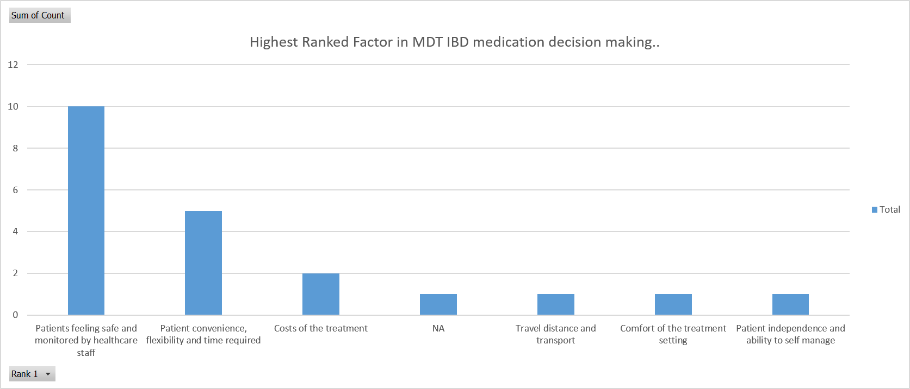
Figure 3. Factors considered least important by Health Care professionals when supporting patients to choose between IBD medications
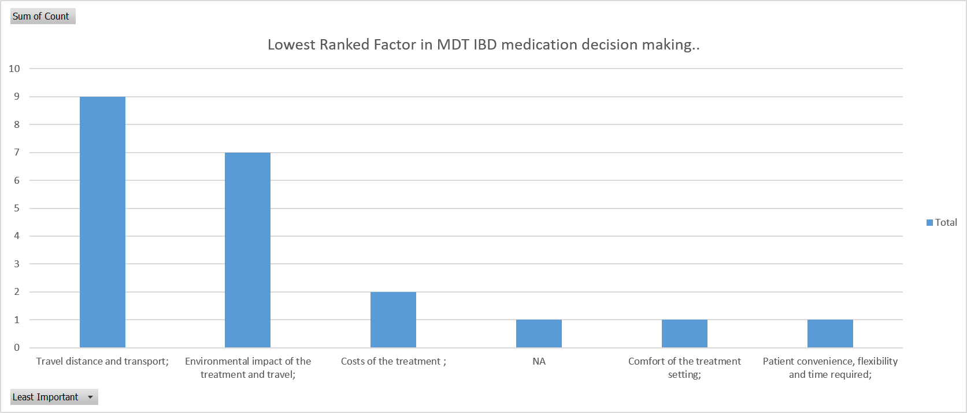
Participants using a Likert scale gave a mean importance to environmental issues in clinical decision making of 5.7 out of 10 (median 5/10), lower than cost considerations which received a mean and median score of 7/10.
16 members of the IBD MDT provided free text comments about sustainability in clinical decision making. 10 (63%) were generally positive but did not currently consider sustainability in clinical decision making:
- “We need to do it”
- “Should be considered but hard to do so when patients referred from all over the shop ….well region”
- “I agree it should be, but at the moment it doesn’t feature prominently in my decision making”
- “Absolutely essential as it's a lifelong disease”
- “It should be considered with the patient”
Six comments (38%) were unsure or negative:
- “Wishful but unlikely to influence”
- “Happy to support green endeavours but don’t think it should be prioritised in the same way as efficacy and cost - sorry (I walk to work though)”
- “Would not influence”
Following the survey, a change in IBD MDT prescribing behaviour was observed, with an increase in the use of SC treatment routes. The responses suggest that this shift may have been influenced predominantly by reassurance around patient safety and convenience, alongside the potential for cost savings, rather than by considerations of environmental sustainability.

We used the opportunity of disseminating the survey to ask staff about their commuting practice for support with another project. It was interesting to see that commuting to work had a higher proportion of lower carbon travel than patients attending for appointments. 7/21 (33%) walked or cycled to work, and 9/21 (43%) travelled by electric vehicle or public transport (<0.100 KgCO2e/mile). How members of the MDT attend work is shown below divided by distance from the hospital, as you can see no member of the IBD MDT travelling over 10 miles used public transport, walking or cycling. This is perhaps unsurprising, as staff are more likely to live closer to their workplace, resulting in a higher proportion walking or travelling by bus, as reflected in the graph below.

Figure 4. How staff commute to work by distance travelled
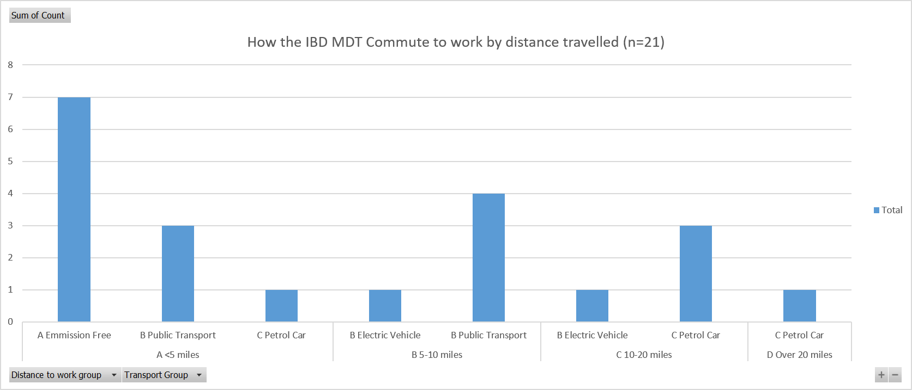

Conclusion
The transition from IV to SC Vedolizumab offers operational, environmental and economic benefits. Based on the observed acceptance rate of 63%, it is estimated that approximately 114 patients from the baseline IV cohort could transition to SC treatment. This would reduce hospital activity by around 742 infusion attendances per year, release approximately 556 hours of nursing time (equivalent to almost 70 eight-hour nursing shifts), and reduce carbon emissions by an estimated 11,570 kgCO₂e annually, principally through avoided patient travel.

The project identified a modest direct financial saving of approximately £6,300 per year through reduced medication and consumable costs. Additional benefits arise from the release of nursing capacity and reduced demand on hospital infrastructure, although these represent efficiency gains rather than direct cash-releasing savings.

For some patients, SC treatment may provide greater independence and flexibility by reducing the need to attend hospital for treatment, which may be particularly beneficial for those balancing work, travel, caring responsibilities or parking requirements. However, patient survey findings demonstrated that treatment decisions were primarily influenced by factors such as safety, convenience, monitoring and ongoing contact with healthcare professionals rather than environmental considerations. Many patients valued the reassurance provided by hospital-based care and regular interaction with clinical teams.

Although SC Vedolizumab reduces the need for hospital attendances and associated consumables, uncertainty remains regarding the comparative carbon footprint of IV and SC drug manufacture and supply. The principal sustainability benefits identified in this project therefore appear to arise from reductions in travel, consumable use, clinical waste and healthcare resource utilisation.

Overall, the project demonstrates that wider adoption of SC Vedolizumab is clinically feasible and has the potential to support NHS sustainability and service transformation objectives. While patient preferences and clinical considerations should continue to guide treatment decisions, the findings suggest that increasing uptake of SC Vedolizumab could reduce the environmental impact of care, release valuable clinical capacity and deliver modest cost savings.

Appendix – carbon footprinting data and calculations

Hospital administered IV Vedolizumab
The emissions associate with delivering IV Vedolizumab includes the consumables (production, raw materials, manufacturing), waste disposal and patient travel. Weights and material composition of the equipment used were identified and supplied by the team and are shown in Table 1 along with the emissions for the raw materials and production.

Table 1 Inventory for consumables, weights, emissions factors, and the carbon footprint for delivery IV.
Components used |  | Number | Emissions per item (kgCO₂e) | Total emissions (kgCO₂e)
1 Clinell wipe to clean tray for Vedo | Clinell wipe *1 | 1 | 0.021 | 0.021
H20 10ml plastic | 10ml saline flush | 1 | 0.047 | 0.047
Hexi hub 2% chlorhexidine 70% alcohol wipe to clean Vedo rubber top | Alcohol wipes - single packet | 1 | 0.0033 | 0.0033
Clean with Clinell wipe | Clinell wipe *1 | 1 | 0.021 | 0.021
Nacl 0.9% 250mls | Sodium chloride 0.9%, intravenous infusion bag | 1 | 0.146 | 0.146
Giving set - Infusomat Space Line | Intravenous infusion giving set | 1 | 0.091 | 0.091
Draw up with 5ml plastic syringe | Syringe 5ml | 1 | 0.033 | 0.033
Needle 21G | Needle (inc packaging) | 1 | 0.003 | 0.003
Gloves pairs x3 in total | Nonsterile glove (single) | 6 | 0.026 | 0.156
Aprons | Apron | 3 | 0.065 | 0.195
Cannulate patient then clean tray with Clinell wipe x1 | Clinell wipe *1 | 1 | 0.021 | 0.021
Luer lock with plastic cover | Luer lock | 1 | 0.001 | 0.001
3ml Posi flush | Posi flush + packaging | 1 | 0.045 | 0.045
ANTT - BRAUN cannulation pack | Cannulation pack | 1 | 0.210 | 0.210 (*)
Total |  |  |  | 0.992
(* includes torniquet which had been listed in addition to the ANTT cannulation pack)
Information on the components of the ANTT Braun canulation pack were taken from the Braun website. https://www.bbraun.co.uk/content/dam/b-braun/en_gb/website-6/documents/products/therapies/infusion-therapy/antt-cannulation-packs/Standard-ANTT%20Cannulation%20Packs%20Brochure.pdf

Estimates of the materials and weights were gathered for the component parts and using these, an estimated carbon footprint was calculated in Table 2.

Table 2. Inventory for components, likely main materials and estimated weights for the ANTT Braun canulation pack with estimated carbon footprint.
Component | Main materials | Estimated unit weight (g) | Estimated carbon footprint kgCO₂e)
Caresite® needle-free extension | Polycarbonate housing, polypropylene connectors, silicone valve | 3 to 6 g | 0.010
Omniflush® pre-filled syringe | Polypropylene syringe barrel and plunger, elastomer stopper, saline solution | 12 to 18 g | 0.039
ChloraPrep® 1 mL applicator | HDPE/PP plastic body, polyurethane foam tip, antiseptic solution | 3 to 5 g | 0.010
Tegaderm™ IV transparent dressing (1633) | Polyurethane film, acrylic adhesive, paper release liner | 2 to 4 g | 0.010
Tourniquet | Synthetic elastomer (latex-free), polypropylene fastening clip | 8 to 15 g | 0.074
Patient underarm drape (40 × 40 cm) | Polyethylene-coated nonwoven cellulose/polypropylene fabric | 8 to 15 g | 0.030
Gauze swabs (5 × 7.5 × 7.5 cm) | 100% cotton | 3 to 6 g | 0.037
Total |  |  | 0.210
Emissions from the raw materials, manufacture of consumables was 0.992 kgCO₂e.
Waste
The total weight of the consumables is about 187g. It is anticipated that all is disposed of in the clinical waste stream. Emissions per tonne for disposal is 1074 kgCO₂e.
Total emissions from waste are 0.802 kgCO₂e.

One way distance average = 20.3 miles (info from Health Outcomes of Travel Tool). Return trip is 40.6 miles.
Emissions per miles travelled for average petrol car = 0.334 kgCO₂e per mile
Total emissions = distance travelled * mode of travel emission factor
Average emissions per visit is 40.6 * 0.334 = 13.56 kgCO₂e.

Summary
The total emissions associated with the raw materials, manufacture and waste disposal of the consumable equipment is 0.992 + 0.802 = 1.79 kgCO₂e per administration of IV Vedolizumab.
Emissions per patient
Consumables, waste disposal 1.79 kgCO₂e
Patient travel (average) 13.56 kgCO₂e
Total 15.35 kgCO₂e per injection

Sub cut self-administration
Patients receiving SC injections typically receive 4 injections per delivery, plus sharps bin and intermittently skin prep wipe.
Consumables
Emissions per alcowipe are 0.0033 kgCO₂e per injection. For 4 injections, this is 0.012 kgCO₂e.
Emissions for a small sharps bin (SHARPSGUARD® eco yellow 0.3 - Daniels Healthcare) based on an empty weight of 71.8g is about 0.228 kgCO₂e.
Pack of 10 gauzes have emissions of 0.185 kgCO₂e.
Total emissions to deliver 4 SC injections is 0.425 kgCO₂e.

Transport
The weight of the package received by the patients is not known, nor the courier and vehicle type used for deliveries.
Roughly, emissions of 0.25 kgCO₂e for a 250g package are a mid-point estimate.
Patients receive four pens in a delivery and deliver their SC dose every 2 weeks. Each delivery lasts the patient 8 weeks. Over 2 years, there would be a total of 13 deliveries – or 6.5 deliveries per year. In the first year they would receive 7 deliveries, in the second year, 6 deliveries.
Based on 181 patients there would be 181 * 7 deliveries per year = 1,267 deliveries.
If the weight of the package delivered is 250g, then emissions would be around 1,267 * 0.25 = 316.75 kgCO₂e.

Waste
Waste disposal of a small sharps bin with a maximum filling weight of 0.17kg via the clinical waste stream (emissions per tonne for clinical waste disposal is 1074 kgCO₂e) has emissions of 0.18 kgCO₂e.
If one small sharps bin is required with every delivery of 4 injections, then emissions associated with waste disposal are 391 * 0.18 = 70.38 kgCO₂e. However, one sharps bin may last a patient longer and so a lower number required across one year.

Summary
Emissions to deliver 4 injections
- Consumables 0.425 kgCO₂e
- Transport 0.250 kgCO₂e
- Waste 0.18 kgCO₂e
In the first year (for 7 deliveries), total emissions are 0.855 kgCO₂e per 4 SC injections, 5.99 kgCO2e per patient.

Carbon footprint pharmaceutical industry summary
We met with Takeda, who supply homecare SC Vedolizumab, however their carbon footprint was close book to the Newcastle Hospitals. Therefore, comparing the carbon footprint of SC and IV Vedolizumab is beyond the scope of this project.

Consequently, environmental sustainability benefits are likely to result from reduced hospital resource utilisation, lower consumption of materials, and decreased waste generation within the hospital setting.

