SUSQI PROJECT REPORT

Project Title: Reducing The Amount of Wasted Food In Hampshire Hospitals Foundation Trust | 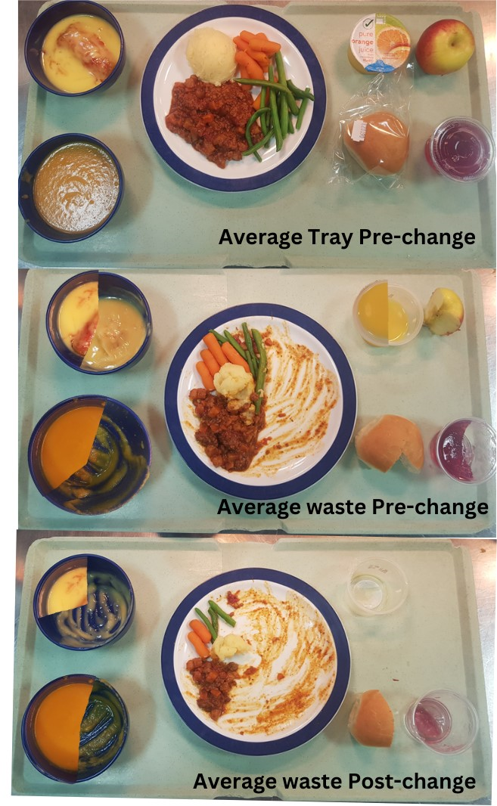
Start/End date of Project: June 2023
Date of Report: 16th August 20023
Team Members:
Robert Strachan, Head of catering
James Freeburn, Catering Administration Lead/ Facilities Project Lead
Teri Hope, Facilities Admin Lead
Daniel Freeman, Head Chef
Daniel Ellston, Chef

Background:
Across UK hospitals, approximately 0.5 kilograms of food waste is produced per patient per week (1). According to the 2020 NHS Hospital Food Review (2), this waste costs healthcare services £230 million annually - 39% of the total food budget.

Previous food waste data has shown that Basingstoke and North Hampshire Hospital (BNHH) and the Royal Hampshire County Hospital (RHCH) in Winchester, collective waste ~231 tonnes of food (2021/2022 financial year).

In one week, BNHHl produced over 1,500kg of food waste, equating to an estimated 130,000 kg of food waste a year Trust wide. Other Trusts have successfully reduced food waste by £100,000 per year, a saving equivalent to 3.53% of the Trusts annual non-pay budget for catering. Our catering team in Hampshire saw an opportunity to achieve the same savings, while minimising our environmental impact.

Specific Aims:
To reduce food waste across HHFT, and in doing so
- saving £100,000 per year
- saving 100 Tonnes of CO2e per year
- saving 500,000 pieces of plastic packaging per year.
- adding nutritional value to our patient meals

Methods:
Studying the system:
We started by measuring the amount of food waste that is produced within the Trust, focussing on four key areas:
- Production waste
- Untouched meals
- Plate waste
- Spoilt Foods (data on this aspect of the project is pending and so it has not been included in the remainder of the project report).

It was important that the whole catering department, not just the project team, understood the importance of taking the project seriously and accurately recording the data. To accurately record waste, new food waste bins and scales were purchased, data spreadsheets developed and recording duties were allocated to varied team members. To make the project truly inclusive
- A chef would record the patient lunch waste
- A catering assistant would record the breakfast patient waste
- Catering supervisor to record the evening patient waste
- Kitchen porters to record the production waste
- Storeman to record out of date and spoilt foods and inform head chefs of all thrown away foods
- Catering Administration Lead also audited the returned meal trays to classify the items and proportions of each item that were wasted.

The findings were that wastage was high in all areas, and that packaged items that were otherwise safe to eat were discarded as their condition (temperature and infection wise) was not known (Table 1).

Clinical staff engagement:
We engaged a wide range of clinical staff to provide information on their perceptions for why food may be wasted (particularly in the areas of untouched meals and plate waste). A survey went out to the wards regarding food waste.

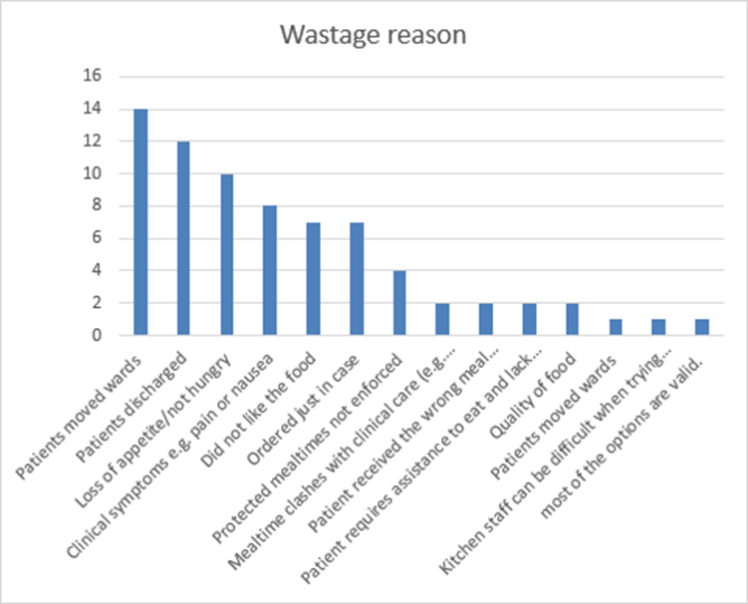
Table 1: Clinical staff perceived reasons for food waste at ward level
Other contributing factors to food wastage that recurred during participants responses include:
- 78% of staff order or are aware of others ordering ‘just on case’ meals for patients known to be leaving or potentially having surgery etc. As the food is cold before a patient returns from a procedure additional meals are requested. On maternity staff reported over ordering so new patients get a meal. Wards knowingly over-ordering as food isn’t available between meals.
- No effort made to communicate discharges or moves to the kitchen.
- 70% of staff think the meal cut off times are too early and 58% believe this contributes to the food waste.
Additional findings with implications on patient experience;
- 54% of staff believe the small sized portion is too large.
- 54% believe the number of courses contributes to food waste.
- 51% of staff feel that 2 courses would be sufficient for patients with 38% feeling 3 courses would be more appropriate (11% selected 1 or 4 courses).
- Only 1/3rd (33%) of staff feel protected mealtimes are respected, with 37% feeling they sometimes are, and 30% feeling they are not.
- Meal choices are made for the patient by staff without asking patient preference.
- Patients with allergies given inappropriate meals / No suitable options (staff seem unaware they can contact catering for special dietary requirements).
- Meals going cold as too few staff giving out meals / Meal times not prioritised or protected on wards / Not enough staff to support patient feeding. Some assistance needs are not met so the patient goes hungry (10 pts. needing support, 4 staff available).
Changes implemented/planned:
We used the information gained above to developed a driver diagram and identify change ideas to tackle each driver of food waste.
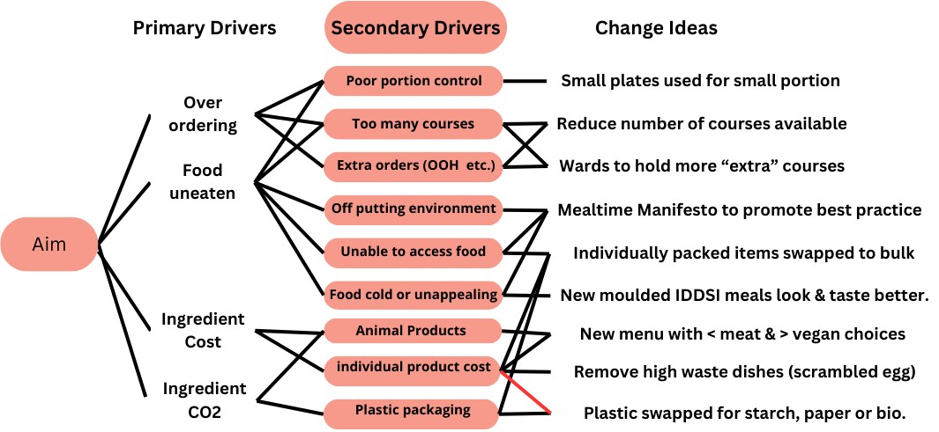
Image 1: Driver diagram for change ideas for food waste reduction
Previously, we had a standard portion size. We have implemented portion size options. We have also reduced the number of courses. Previously the menu was set up in the same way as paper ordering sheets had been:
  - Starter (juice or soup)
  - Roll & Spread
  - Main course
  - Vegetables
  - Dessert (x2)
  - Something for later (healthy snack)
The new menu would have a reduced choice of courses as follows:
  - Main Course
  - Vegetables
  - Additional courses (x2)
In this manner patients would not be able to directly order 2 puddings and soup and roll (although they could still order 1 and soup and roll) or a healthy snack. By offering portion sizes and reducing food on the tray patients should be less overwhelmed and comfortable to eat more of the food given.
Both additional puddings and healthy snacks would instead be given to wards to hold locally for occasions when patients are hungry after or between meals. There is evidence that wards holding food can improve patient nutrition out of hours, as per the independent review of NHS hospital food recommendations on 24/7 access to nutrition and hydration.
A mealtime manifesto has been produced to promote best ward practice and create a positive environment for patients during meal times. While this has been produced as part of the project it was not widely dispersed during the measurement period.
Individually wrapped items, where possible, were swapped to bulk packaged goods. This included cereals (from 25-40g individual packs to catering size packs) and juices from individual cuplets to litre cartons. This reduction will reduce the amount of plastic packaging and reduce cost, while improving patient nutrition and hydration, as previous ward audits found that individual packs were not always opened for patients who couldn’t open the packets themselves.
Redesigned Menu
A new menu plan was created, with a focus on moving high cost and high CO2e producing ingredients, such as red meats, swapped for lower cost/CO”e options, as well as removing high wastage items.
- Scrambled egg was found to be a high waste item that isn’t commonly accessible in other trusts, so was removed entirely.
- The 4 main course choices at lunch and 2 at supper have traditionally been:
    - Meat 1 (Lunch and Supper)
    - Meat 2 (lunch only)
    - Fish (Lunch only + some suppers instead of Meat 1)
    - Vegetarian (Lunch and Supper)
- This was amended to Lunch:
    - Meat (Low cost & Low CO2 - mainly chicken)
    - Fish
    - Vegetarian or Vegan (alternating)
    - Meat vegetarian or vegan (alternating)
- Supper:
    - Meat or Fish
    - Vegetarian or Vegan (alternating)
This reduction has reduced 3 meat 1 fish and 2 vegetarian dishes to roughly 2 meat, 1 fish 2 vegetarian and 1 vegan dish choices daily, thereby reducing meat and animal produce purchased by 10%. Meat recipes still on the menu such as beef and Lamb (high cost, high CO2) have been swapped to chicken, turkey and pork.
The recipes included and vegetable sides were amended to include more locally grown, in season ingredients to be changed on a 6 monthly basis to make the best use of local produce at a lower financial and environmental cost.
Where possible unnecessary packaging has been removed, while remaining packaging has been exchanged to paper, starch or bio-plastics. While increasing cost, this will support a reduction in CO2 emissions and environmental impact.
We also reviewed menu items for International Dysphagia Diet Standardisation Initiative (IDDSI - special texture) meals. New moulded IDDSI meals were bought in to replace the old supplier. Following a taster session the new variety were found to be more nutritious, better tasting and more visually appealing. While slightly more expensive, it was hoped increased nutrition for our most vulnerable patients would support their recovery and therefore reduce their time in the hospital.

Measurement:
Patient outcomes:
Our survey with ward staff highlighted that food waste has implications on patient experience, and we have detailed some of the potential positive impacts on patients as a result of our changes in the results section.

Additionally we have looked at the length of patient stay as an indirect measure of patient nutrition, to ascertain whether menu changes have had an impact on patient recovery. We have also looked at patient feedback following the change to assess positive and negative impacts.

Environmental sustainability:
The CO2e of changes and reductions to food procurement/ordering/delivery to hospital, we calculated kgCO2e/kg or kgCO2e/item based on carbon emission factors from Small World Consulting.
Food waste disposal - 8.912 kgCO2e/tonne (taken from BEIS 2023 - Greenhouse gas reporting: conversion factors 2023 - GOV.UK (www.gov.uk).
Economic sustainability:
To start the project we purchased:
- 3 sets of 15Kg scales @£149
- 6 food waste caddie bins @ £8
- Total investment spend: £495

To calculate savings we used the cost of purchased foods and the cost of food waste disposal. Costs of foods were calculated from 2 locations - order form data, with current supplier pricing applied as well as invoice data recorded onto our inhouse (Menumark) system.

Social sustainability:
The staff questionnaire (used to inform change ideas) supported us to gain qualitative information on social impacts on patients and staff from food waste.

We spoke to patients informally on the wards.

Results:
Patient outcomes:
During ward visits patients and relatives were spoken to regarding food quality and portion sizes. Prior to our changes, patients (mainly elderly) commented on portion sizes being large and putting them off their meal.

The staff survey stated that one of the main reasons for food waste was loss of appetite whilst in hospital. It is important to encourage patients to eat as one third (32%) of people in the UK aged 65 years or over are at risk of malnutrition on admission to hospital Malnutrition in England factsheet | Malnutrition Task Force.

We were sure to include IDDSI meals as part of this project so patients requiring specialist textured diets were not excluded. We also found additional benefits from switching to individually packaged items like cereal and juice may support access for some patients.

Our focus to make sure small portions are small and look appetising, and that foods are accessible appears to have been successful in supporting patient appetites. From the combination of reduced wastage and increase in production of hot food (figures to follow) it was ascertained that patients are consuming more of the hot (more nutritious) food (main courses and desserts mainly). This increase in patient nutrition is believed to have contributed to a reduction in the average length of patient stay through an enhanced recovery rate (Table 3). While this is unlikely to be the only contributing factor to the overall reduction, based on the preliminary data, it may well have been a significant factor and the overall length of stay is now displaying the beginnings of a statistical shift (13 out of 14 weeks have been below average, with the one week above being a week of 4 days of Dr Strike action which would have significantly impacted patient discharge times)).
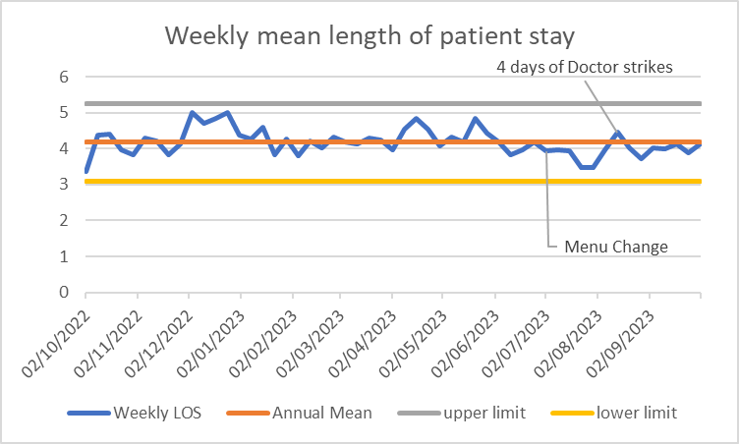
Table 3. Average length of patient stay taken from Trust held BI data.

Environmental and Economic sustainability:

Purchasing and menu changes
The reduction in ingredient cost and menu courses has led to an overall decrease in purchasing. Some of this can be seen in run chart 1 (Appendix 1).

Our reduction in ordering and menu changes have resulted in significant financial and carbon savings. For a full breakdown of this data, please see Appendix 2.
Summary:
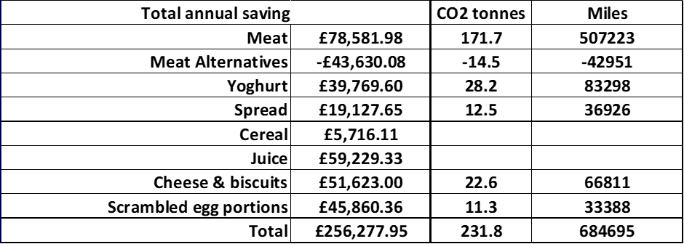

Plate waste and untouched meals
From the Catering Admin Lead’s audit, full items given to patients and plate wastage has reduced by 24% (data in Appendix 3). The financial and carbon savings of this will be included in the above calculations for reduced ordering and menu changes.
Financial impact:
Based on our order sheet data, the total annual saving is £256,277.95 trust wide. However, this does not account for our full increase to veg and meal alternative purchasing or other purchasing factors. Therefore, we used invoice data to identify annual savings of £112,791 at our BNHH site. Of this, approximately £14,581.56 is from full items uneaten and plate waste and £98,209.44 from menu changes.
Using the invoice data and average patient numbers at RHCH, we have estimated potential savings at our RHCH site.
Therefore, we anticipate total savings of approximately £157,135 per year across both sites / Trust wide.
Environmental (CO2e) impact:
With the menu changes accounted for, the purchasing data studied before and after the change shows a reduction in approximately 231,800 kgCO2e Trust-wide annually. However, this also does not account for our full increase to veg and meal alternative purchasing or other purchasing factors. We have therefore made a 38% reduction (in line with financial savings) to conservatively estimate a saving of 143,716 kgCO2e per year, equivalent to driving 424,442 miles in an average car, roughly 17 times around the circumference of the Earth.

Single use plastic reduction:
A reduction of plastic packaging has been calculated from (for BNHH only):
- Non-plastic and reduced dessert pots - 274802 pieces annually
- Removal of individual juice cuplets - 235846 pieces annually
- reduced number of patient rolls served - 5615 pieces annually
- Reduced number of pre-packaged or wrapped sandwiches and salads served (in favour of hot meals) - 28076 pieces annually.
- Removal of individual cereals - 71760 pieces annually
Total plastic reduction for BNHH is calculated to be 616,099 pieces annually. The data for this has come from purchasing data and the plate waste breakdown review.

We have also shown the reduction in food waste below using images:

Picture 1. Representation of the average tray pre change, average wastage pre change and post change (as pie charts) for each of the tray items, as per the findings in Table 5.

In the first 3 weeks of recording there were 2,844 untouched meals equating to 1057 kg of wasted food. In the 3 weeks up to 25th September we had reduced this by 10.33% to 2,550 untouched meals weighing 1,006 kg, a decrease of 4.8%. = 51kg saved (0.051x x 8.912 = 0.45 kgCO2e) in 3 weeks. 7.9kgCO2e across the year.

Food Waste Data October 31st 2023

 | BNHH | RHCH | Trust
01/06/23  31/07/23 | 11,322 Kg | 9,453kg | 20,775kg
01/09/23/  31/10/23 | 9376kg | 9,247kg | 18,623kg
Reduction | 1,946kg  17.18% | 206kg  2.17% | 2,152kg  10.35%

A reduction of 10% has been achieved trust wide. RHCH started their recording and reducing waste project later than BNHH which is showing a 17.18% reduction
Since the launch of the project BNHH has shown a reduction from 5686Kg a month in June to 4340kg in October, a reduction of 23.6%.
The project team feels that now the drive has started and figures are showing that we are reducing the waste and we can set further SMART targets to reduce food waste

With a reduction of 24% plate waste annual disposal costs for both sites could decrease by up to £4984.30 (24% reduction on current food waste removal costs) although this has yet to be proven.

Social sustainability:
The Catering manager explained in detail to chefs and the catering team about overproduction and the amount of water, food miles and energy that is used to produce our ingredients. Combined with labour and resources for food production there should be a social and moral drive to reduce the amount of food we waste.

The importance of the protected mealtimes for patients and making meals accessible has been brought into focus and work is ongoing with ward teams about the importance of this. This is important for patients' experience of mealtimes and their care, but will also have health benefits as described in the clinical impacts section.

Patient feedback has been received via social media highlighting positive responses to the menu change:
- Shout out to the catering team (Basingstoke site) I just wanted to share some feedback I've had on Maternity over my past few shifts "I'm a vegan, I thought I’d be living on lettuce leaves and bread, but the food has been brilliant. I'm amazed at the choices for vegans.'
- ‘I seriously can't wait for my food to come. It’s so good. The quorn cottage pie was my favourite. It had a real kick'
- ‘I've loved the food here. It's really good. My favourites have been the veg curry, and the fish pie today was delicious. The chicken I had today was so good. Full of flavour' So, credit where it's due. It's a shame you don't have feedback forms. Well done to the catering team!’

Further to this the Patient Led Assessment of the Care Environment (PLACE Audit) at Winchester highlighted the new menu as a positive: “Very good and well presented and the temperature was good”

Discussion:
Following an imposed change in menu, beyond the general staff's control, the main obstacle in driving down the amount of food waste is changing people's habits and mindsets. By supporting staff across the catering and clinical environments to understand the interconnections between food, food waste, patient experience and environmental impacts, we aim to overcome these barriers.

There will always be variation in amounts of waste due to the nature of the catering service. The hospital is usually in the quieter months over summer when our project data was collected, so close monitoring will be required during the winter.
HHFT are also required to send food waste data as part of the ERIC (estates return information collection) returns
Wrap now known as the Guardians of Grub have produced signage and tools to assist with food waste.

References and Resources
- Food waste in the NHS | WRAP
- Report of the Independent Review of NHS Hospital Food (publishing.service.gov.uk)
Appendices

Appendix 1:
The reduction in ingredient cost and menu courses has led to an overall decrease in purchasing. Some of this can be seen in run chart 1 below. The data has a proven shift in data of 7 cycles all below the mean following the implemented change so averages have been recalculated (RHCH Data is incomplete, but shows comparable data).

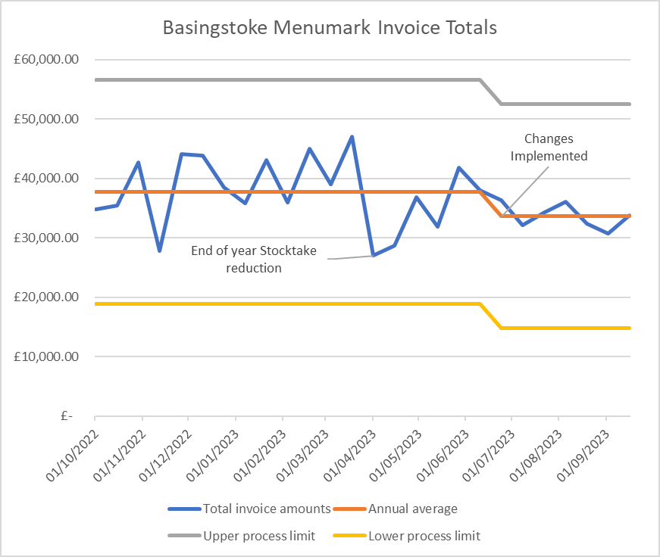
Run Chart 1. Graphical representation of BNHH food only invoice data..

Appendix 2:

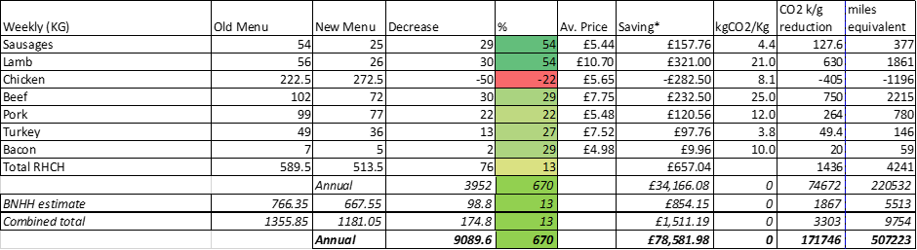
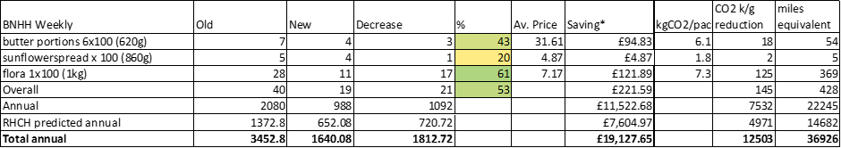
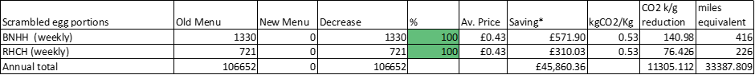
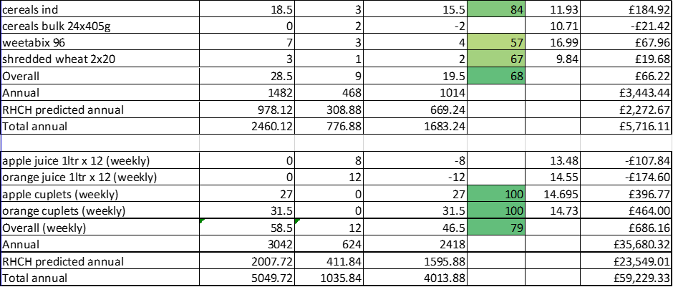

Appendix 3: Breakdown analysis and totals of plate waste audits.

